- Explain SDLC with an example with a neat diagram?
Software Development Life Cycle (SDLC) is a process used by the software industry to design, develop and test high quality softwares. The SDLC aims to produce a high-quality software that meets or exceeds customer expectations, reaches completion within times and cost estimates.
The life cycle defines a methodology for improving the quality of software and the overall development process. Each stage produces deliverables for the next one.
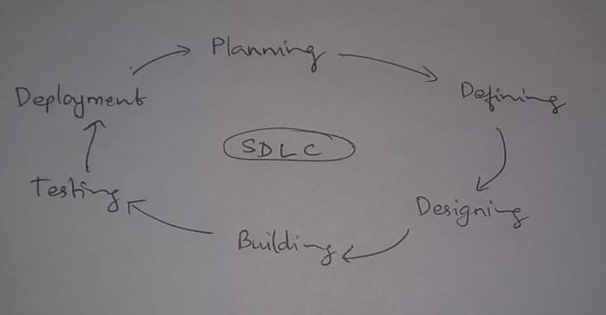
SDLC consists of the following stages −
- Planning and requirement analysis. After a customer and a vendor initiate a project, the project manager on the vendor’s side assigns the project team. Together with the customer, they define the project scope through requirement gathering and analysis.
- Defining. At this stage, the developers prepare a system design and define the overall system architecture. The PM decides on the software development approach and pricing model. Then, the project team gets down to implementing and integrating the required features.
- Designing and Building Software Requirement Specification s the reference for product architects to come out with the best architecture for the product to be developed. Based on the requirements specified in SRS, usually more than one design approach for the product architecture is proposed and documented in a Design Document Specification and is is reviewed by all the important stakeholders and based on various parameters as risk assessment, product robustness, design modularity, budget and time constraints, the best design approach is selected for the product. Based on Design Document Specification the actual development starts and the product is built.Developers must follow the coding guidelines defined by their organization and programming tools like compilers, interpreters, debuggers, etc. are used to generate the code. Different high level programming languages such as C, C++, Pascal, Java and PHP are used for coding. The programming language is chosen with respect to the type of software being developed.
- Testing Now, testing engineers check the software to ensure that its quality is acceptable and the product serves the intended purpose. The developers fix bugs.
- Delivering product to the customer. After testing and bug fixing, the final version of the software is delivered to the customer.
- Maintenance and support. The project team takes care of the developed product even after its release, improving it upon the customer’s request and continuously troubleshooting the product.
Content management system- CMS
First Discussing the project scope, led to investigation and found out that the customer needed to turn around their content management system (CMS) to create a brand-new product with advanced UI. The new CMS was to provide the most intuitive and efficient way to create and manage websites, intranets and mobile solutions for enterprises.
Jotting down the needs of the user as well as the company side intended for the part of defining and designing which indeed would create a Design Document Specification and the development and coding part would strictly reside on the specifics. The coding team would provide the product strictly adhering to the DESIGN DOCUMENT SPECIFICATION.
At the solution stabilization stage, a test automation specialist ensured that the system worked as intended. The custom web framework we created specifically for this project facilitated continuous and efficient testing.
Then the product will be finally delivered to the customer. The requested client will be provided with an innovative CMS platform with modern and flexible architecture.
The SLDC maintenance team will be supporting and maintaining the platform for a defined time frame.
2). Calculate avg. waiting time of 4 processes for FCFS and Round Robin?

FCFS Method
Consider the following 4 processes

Process | Arrival Time(sec) | Execute Time(sec) | Service Time(sec)
P0 | 0 | 6 | 2
P1 | 1 | 4 | 4
P2 | 2 | 2 | 3
P3 | 3 | 5 | 5

Wait time = service time - arrival time
Wait time of each process,
T0 = 2 - 0 = 2 sec
T1 = 4 - 1 = 3 sec
T2 = 3 - 2 = 1 sec
T3 = 3 - 2 = 1 sec

So, avg. waiting time T = (T0+T1+T2+T3)/4
= (2+3+1+1)/4
= 1.75

Round Robin Method

Process | Arrival Time(sec) | Burst Time(sec) | Priority
P0 | 0 | 6 | 1
P1 | 1 | 4 | 4
P2 | 2 | 2 | 3
P3 | 3 | 5 | 2

Gantt Chart

Let time slice = 3 sec

P0 | P3 | P2 | P1 | P0 | P3 | P1
0 3 6 8 11 14 16 17

Waiting time for each process
T0 = (0-0) + (11-3) = 8 sec
T1 = (8-1) + (16-11) = 12 sec
T2 = (6-2) = 4 sec
T3 = (3-3) + (14-6) = 8 sec

S0, avg. waiting time, T = (8+12+4+8)/4
= 8 sec

3.Explain Inheritance , Polymorphism, Class and Object?
Inheritance is one of the significant features of an object-oriented programming language. This is a special feature as it reduces programmers re-writing effort.
Inheritance can be defined as the procedure or mechanism of acquiring all the properties and behavior of one class to another for example acquiring the properties and behavior of child class from the parent class.The main advantage of INheritance is creating a new class that gets built upon an already existing class,Thus aiding in code reusability.The class that gets inherited taking the properties of another class is the derived class or child class. The class whose properties get inherited is the superclass or parent class.There are different types of Inheritance namely single inheritance ,Multi Inheritance and hierarchical inheritance.
Polymorphism
Polymorphism is a feature of object oriented programming which provides the object the ability to take many forms.There are mainly two types of polymorphism static polymorphism and dynamic polymorphism.Static polymorphism is achieved by method overloading.Dynamic polymorphism is achieved by method overriding .
Class
A class describes the contents of the objects that belong to it, describes different data fields and defines the different methods or functions. It can also be defined as a set of code that holds the different functions and variables and helps in creating class objects, initialising values to variables and carries out the implementation of member functions and classes.

Object
Object can be defined as an instance of a class.Objects are created from the class definition and can have a state and a behaviour where the values stored in the variables of the instance is the state and the different member functions are the behaviour of the object.

4. Explain each process in Software evolution?
The process of developing a software product using software engineering principles and methods is referred to as software evolution. This includes the initial development of software and its maintenance and updates, till desired software product is developed, which satisfies the expected requirements.
SOFTWARE EVOLUTION CYCLE DIAGRAM-
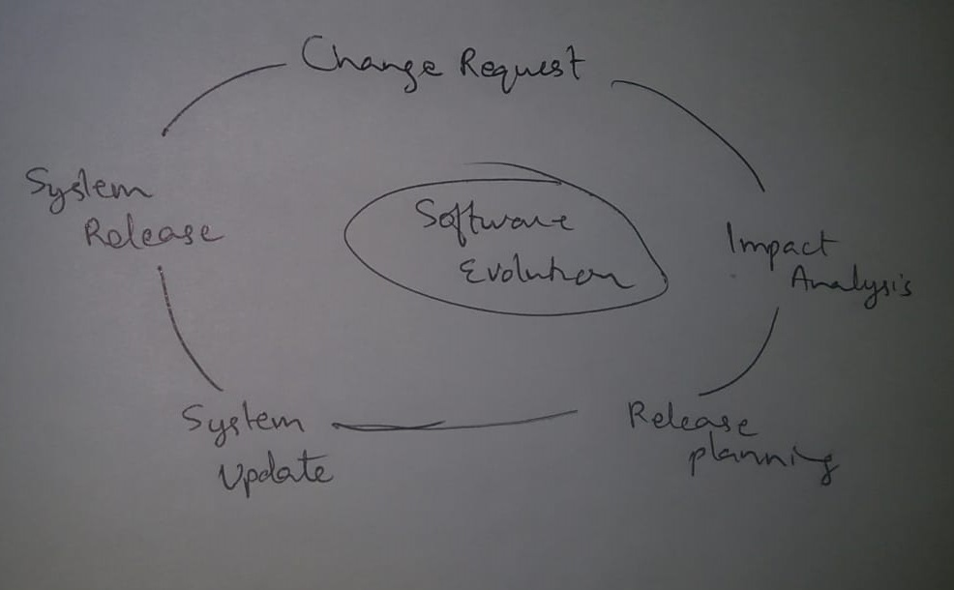
- S-type (static-type) - This is a software, which works strictly according to defined specifications and solutions. The solution and the method to achieve it, both are immediately understood before coding. The s-type software is least subjected to changes hence this is the simplest of all. For example, calculator program for mathematical computation.
- P-type (practical-type) - This is a software with a collection of procedures. This is defined by exactly what procedures can do. In this software, the specifications can be described but the solution is not obvious instantly. For example, gaming software.
- E-type (embedded-type) - This software works closely as the requirement of real-world environment. This software has a high degree of evolution as there are various changes in laws, taxes etc. in the real world situations. For example, Online trading software.
- Continuing change - An E-type software system must continue to adapt to the real world changes, else it becomes progressively less useful.
- Increasing complexity - As an E-type software system evolves, its complexity tends to increase unless work is done to maintain or reduce it.
- Conservation of familiarity - The familiarity with the software or the knowledge about how it was developed, why was it developed in that particular manner etc. must be retained at any cost, to implement the changes in the system.
- Continuing growth- In order for an E-type system intended to resolve some business problem, its size of implementing the changes grows according to the lifestyle changes of the business.
- Reducing quality - An E-type software system declines in quality unless rigorously maintained and adapted to a changing operational environment.
- Feedback systems- The E-type software systems constitute multi-loop, multi-level feedback systems and must be treated as such to be successfully modified or improved.
- Self-regulation - E-type system evolution processes are self-regulating with the distribution of product and process measures close to normal.
- Organizational stability - The average effective global activity rate in an evolving E-type system is invariant over the lifetime of the product.

5.Explain delays with formulas?
Delays in Packet switching :
1. Transmission Delay
2. Propagation Delay
3. Queuing Delay
4. Processing Delay
Transmission Delay :
Time taken to put a packet onto link. In other words, it is simply time required to put data bits on the wire/communication medium. It depends on length of packet and bandwidth of network.
Transmission Delay = Data size / bandwidth = (L/B) second

Propagation delay :
Time taken by the first bit to travel from sender to receiver end of the link. In other words, it is simply the time required for bits to reach the destination from the start point. Factors on which Propagation delay depends are Distance and propagation speed.
Propagation delay = distance/transmission speed = d/s

Queuing Delay :
Queuing delay is the time a job waits in a queue until it can be executed. It depends on congestion. It is the time difference between when the packet arrived Destination and when the packet data was processed or executed. It may be caused by mainly three reasons i.e. originating switches, intermediate switches or call receiver servicing switches.
Average Queuing delay = (N-1)L/(2*R)
where N = no. of packets
L=size of packet
R=bandwidth

Processing Delay :
Processing delay is the time it takes routers to process the packet header. Processing of packets helps in detecting bit-level errors that occur during transmission of a packet to the destination. Processing delays in high-speed routers are typically on the order of microseconds or less.
In simple words, it is just the time taken to process packets.
Total time or End-to-End time
= Transmission delay + Propagation delay+ Queuing delay + Processing delay

